**CS689 Assignment 3**

Q. Explain elapsed date dimension

This is a date-time dimension which is based on the intervals between one or more dates. This dimension is useful to find out since how long an employee has been employed. There is no usage of absolute dates in this dimension.

Q. How does the pay_change_facts table refer to each dimension.

On inspecting the scripts it is very clear, these attributes are used in the current warehouse to connect forward. That is as follows :-

Employee_dimension 🡪 employee_key with FK employee_key

Location_dimension 🡪 location_key with FK location_key

Calendar_dimension 🡪 calender_key with FK calender_key

Elapsed_days_dimension 🡪 day_key with FK tenure_day_key

Department_dimension 🡪 department_key with FK department_key

The alter command at the end of the script is what makes these foreign key constraints available.

One can use these foreign key references and the diagram below to understand the schema of warehouse.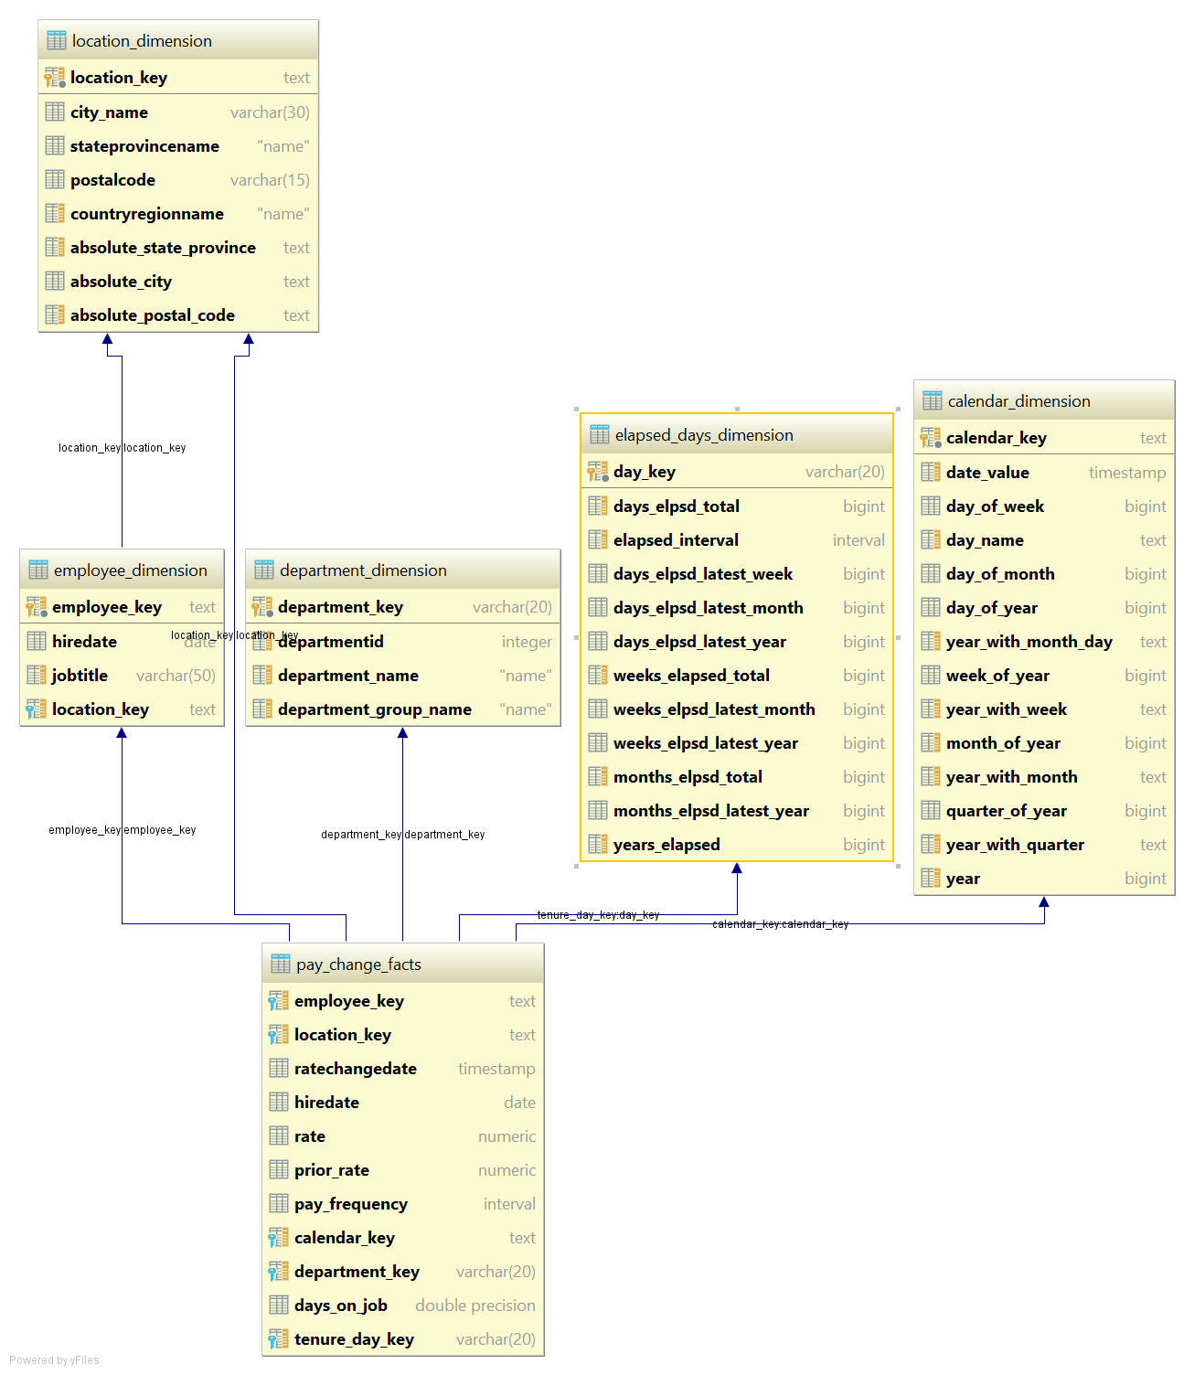

Q. Run each query in the script **when\_are\_there\_pay_changes.sql**. Examine the results. What do the queries tell us about pay changes?

Query 1:

The query calculates and groups number of employees based on ratechangeddate > hireddate condition, assuming rate change date is the date when the got a raise on salary.

Calculates the number of employees who have received the rate change corresponding to the total number of months elapsed it took to get that rate change.

Query 2:

Is same as above but instead of number of months, it uses the months elapsed from latest year field in order to GROUP BY.